This IS A Simple Bank System With A Basic Features :
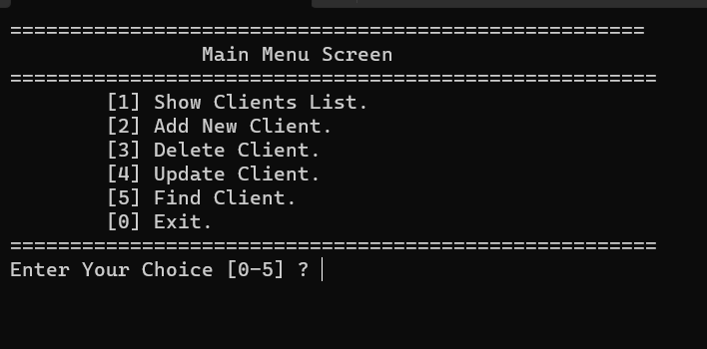

1-Show Clients List From A File (Like Data Base) Inside Project .
2-Add New Client To The File .
3-Delete Client From The File.
4-Update Client From The File.
5-Find Client From The File.

Important Note:
-If You Press 1 And The Program Crashes ->
Delete File Content And Add Clients Again From The Program.

